

Ekorian’s Cultural Walkabout

Immerse yourself in the culture of the remote Samburu people while hiking through some of the best preserved and most beautiful scenery East Africa has to offer. Meet the Samburu going about their daily lives in the raw forest of the Karisia Hills where stunning views and pristine scenery await exploration. Soak up the guide’s local knowledge of trees, herbs and traditional medicines, and let them show you what their life is really about.

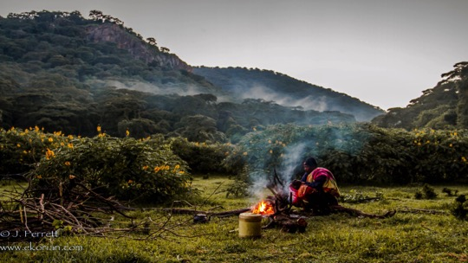

Fly camping:

Set among lush forest in the foothills, this fly camp marries comfort and fine food with a sense of simplicity and wilderness…an intrepid adventure that doesn’t deprive campers of a G&T at day’s end.

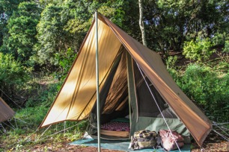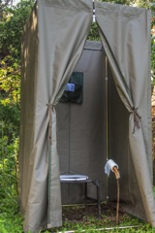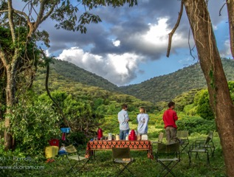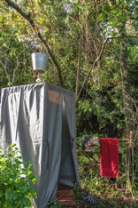

* The traditional A-frame canvas tents sleep two with ample space (twin or double)
* Canvas-walled toilet and shower offer both comfort and privacy. Hot water is prepared on wood fires
* Organic campfire cooked breakfasts, packed lunches and two-course dinners prepared by your safari chef
* Drinks around the campfire with inspiring views of weather playing dramatically across the hilltops

Sample Two-Night Itinerary:

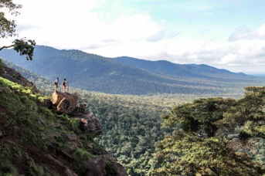**Day One:** Drive one hour from Ekorian’s Mugie Camp to the foot of the Karisia Hills where a base camp of tents around the campfire awaits. Meet your team of guides and trackers and spend the first afternoon familiarising yourself with the area on a short walk in the forest or around the “singing wells” which are dug in the dry season. Evening dinner and drinks around the fire while enjoying the radiant starscape overhead.

**Day two:** Take on a cooked breakfast before walking into the heart of the forest and climbing to the hilltops. Your Samburu guide will take you through the forest without map or GPS - he knows every tree, rock, track and trail. Meet the locals on your way as they collect fire wood, take their cows to water, and go about their daily lives. Your guides will explain the various medicinal and superstitious uses of plants in the forest and point out tracks of the animals living in the area (including leopard, elephant, lion, eland, bush pig, hyena and baboon).

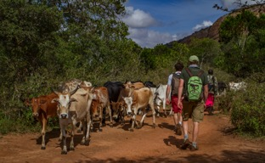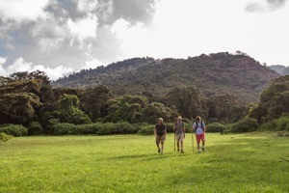

Look out from the 8,000ft hilltop as the breath-taking views of arid, untouched northern Kenya race to the horizon. Have a picnic lunch overlooking this spectacular scenery while numerous species of eagle wheel acrobatically in the cooling winds.

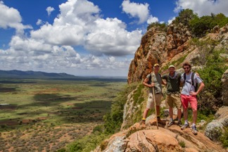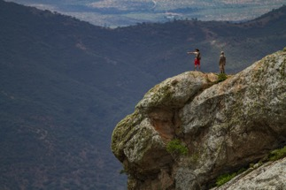

Return to base camp in time for afternoon tea and a competition with the Samburu of “catch the lion” (a game in which warriors practice their spear throwing at a vine wheel being flung downhill). After an open air hot shower, enjoy a wholesome meal around the fire while your Samburu guide and trackers sing songs and tell stories.

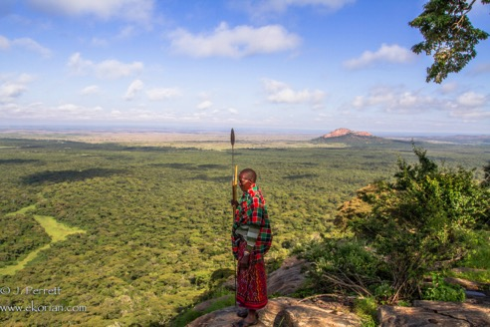**Day 3:** After breakfast, head out of the forest and walk south to climb Naibor Keju (“White Foot Rock”). This standalone outcrop of rock towers to 7,800ft and offers unparalleled views of the Karisia range and the bucolic farmsteads of the local people. Descend from the rock and drive back to Ekorian’s Mugie Camp in time for a late lunch and an evening game drive

[mugiecamp@ekorian.com](mailto:mugiecamp@ekorian.com) Web: [www.ekorian.com](http://www.ekorian.com)

[bookings@offbeatsafaris.com](mailto:bookings@offbeatsafaris.com) Web: [www.offbeatsafaris.com](http://www.offbeatsafaris.com)